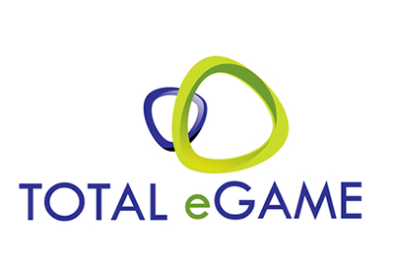

Newsletter

New Game

October - 2015

Game Add on for October:

Launching on 11 October

1. **Titans of the Sun**

Titans of the Sun**,**Hyperion and Theia, in a pair of thrilling games, featuring Wild and Scatter symbols alongside a host of mythical symbols. **Hyperion** heats up the reels whilst the divine **Theia**graces this 15 pay line game with her outstanding beauty.

Both games introduce a brand new on-screen feature; the legendary Mystery Symbols where all Mystery Symbols are stacked across the reels and transform into a single symbol when landing, boosting win potential. With a minimum bet of only 0.15 and impressive wins up to 75 000.00 the treasures of the Titans are well within reach.

**Key Highlights:**

*Available on download, flash*

*15 paylines*

*Achievements*

*Free Games*

*21 languages supported:*

***Full:****da, de,  en, es,  hr (flash only), it, sv, zh*

***Semi:****el, fi, fr , ja, ko, nl , no, pl (flash only), pt , pt-br, ru, tr, zh-tw*

**Titans of the Sun- Hyperion**

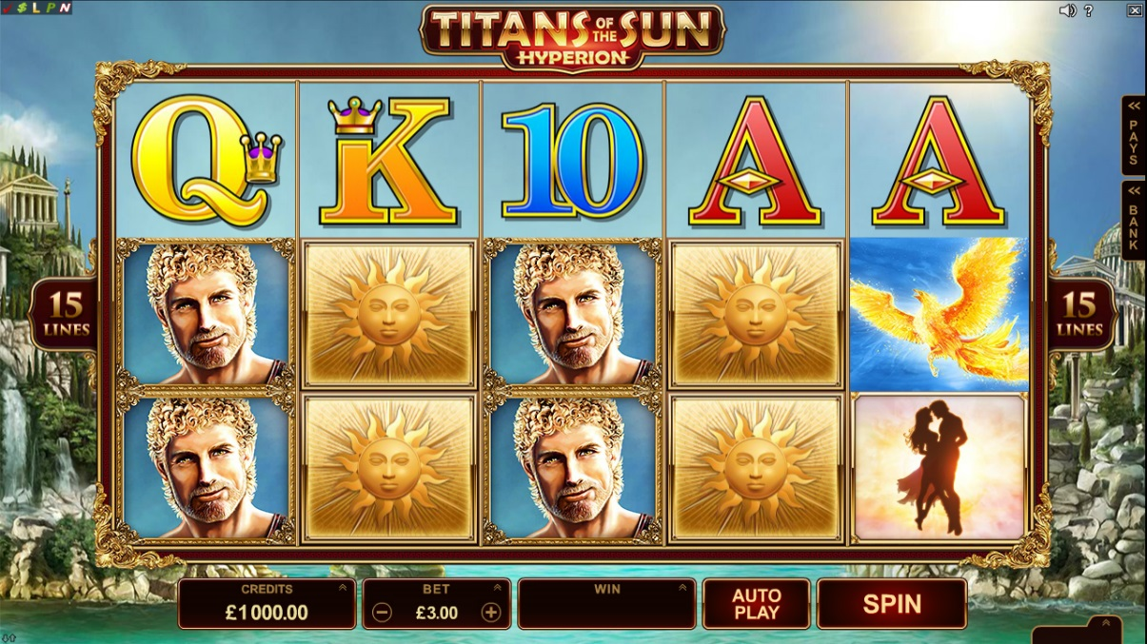

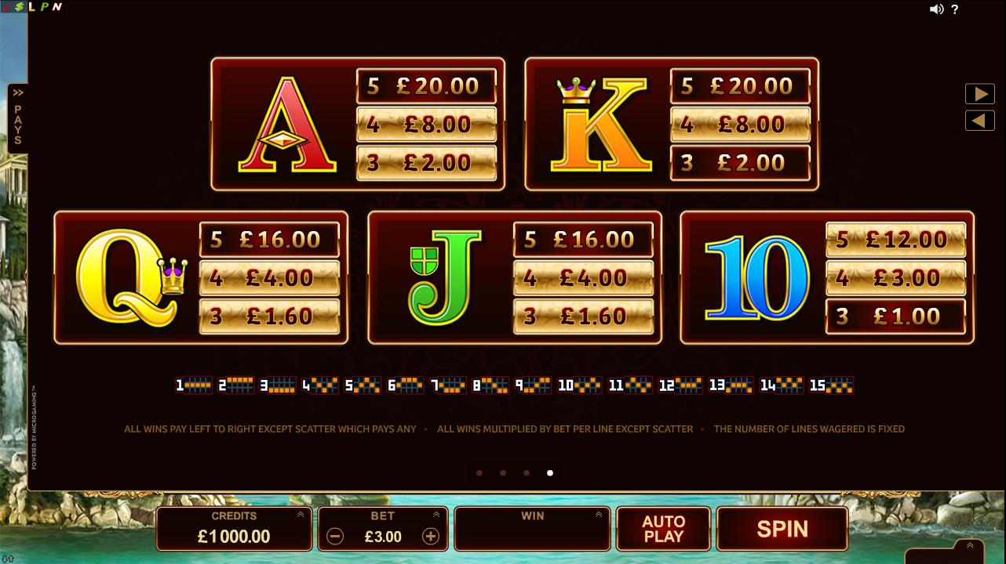

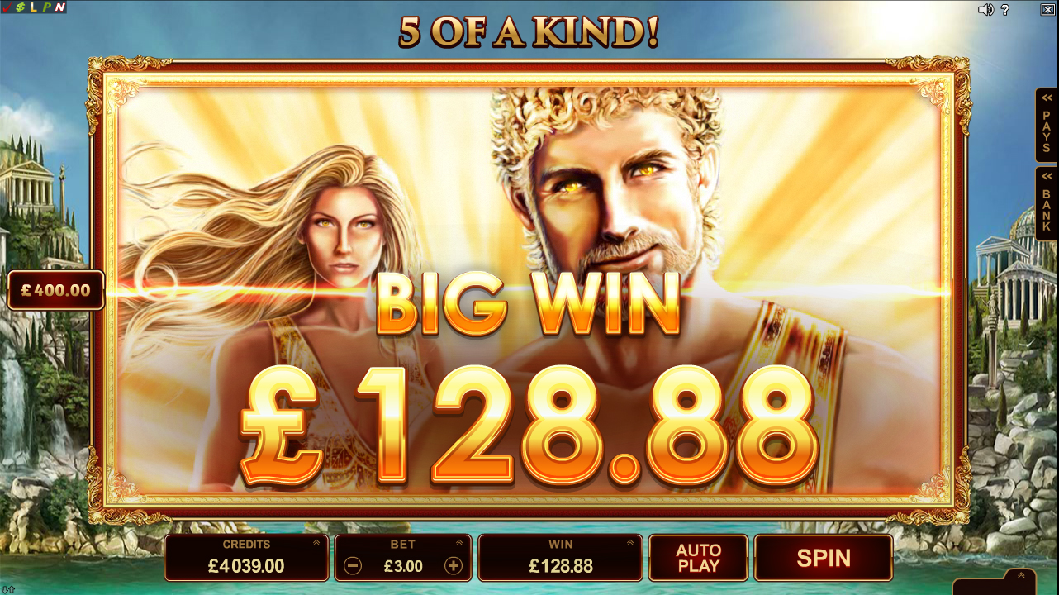

**Titans of the Sun- Theia**

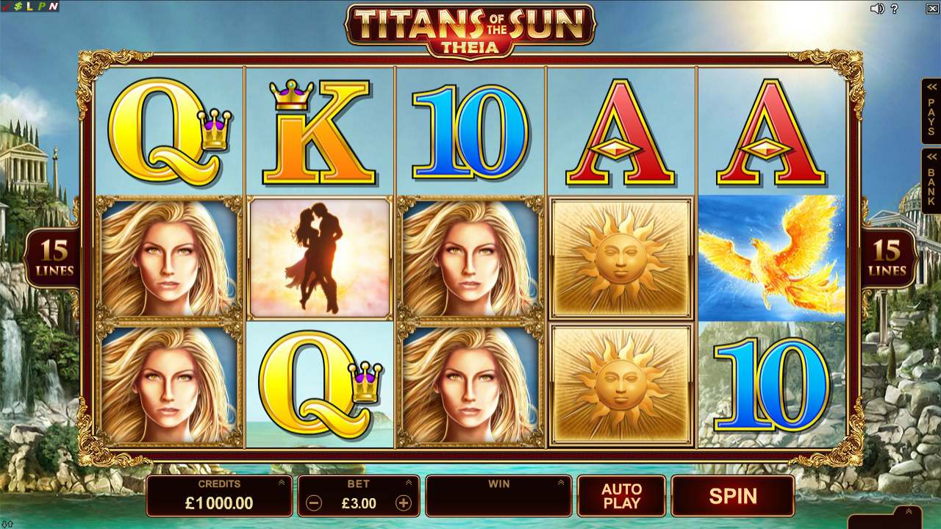

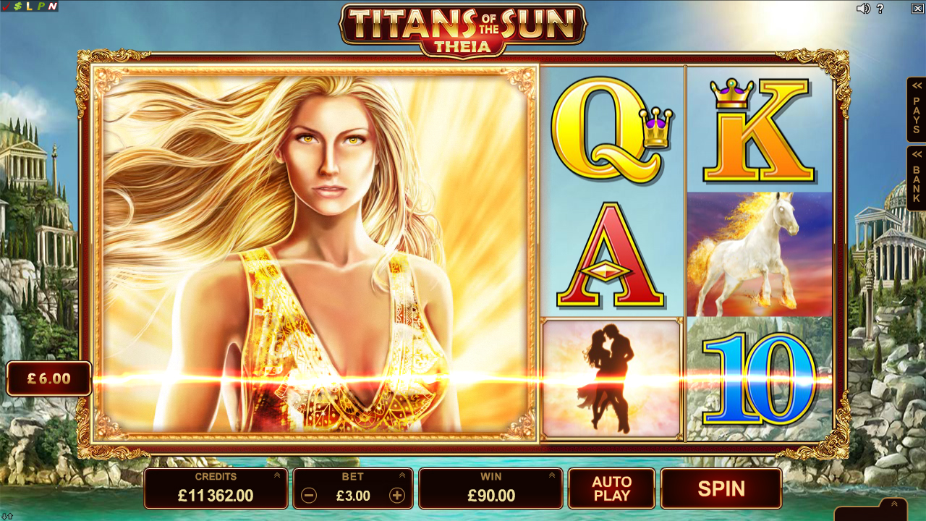

1. **Peek a Boo**

Peek-a-Boo is a captivating and comical game boasting 40 paylines in the base game diverging to 1024 Ways to win in free spins! In the base game, Peek-a-Boo’s quirky kid symbol on reel 3 will randomly zap ghosts on the other reels with his electric ray gun to award cash prizes. Each ghost zapped will be collected in the ghost meter and counted up as a free spin. Once 10  or more of these ghostly apparitions are collected in the Ghost Meter, the free spins feature is triggered!

**Key Highlights:**

*Available on download, flash, CiB and CiP*

*15 paylines*

*Achievements*

*21 languages supported:*

***Full:****da, de,  en, es,  hr (flash only), it, sv, zh*

***Semi:****el, fi, fr , ja, ko, nl , no, pl (flash only), pt , pt-br, ru, tr, zh-tw*

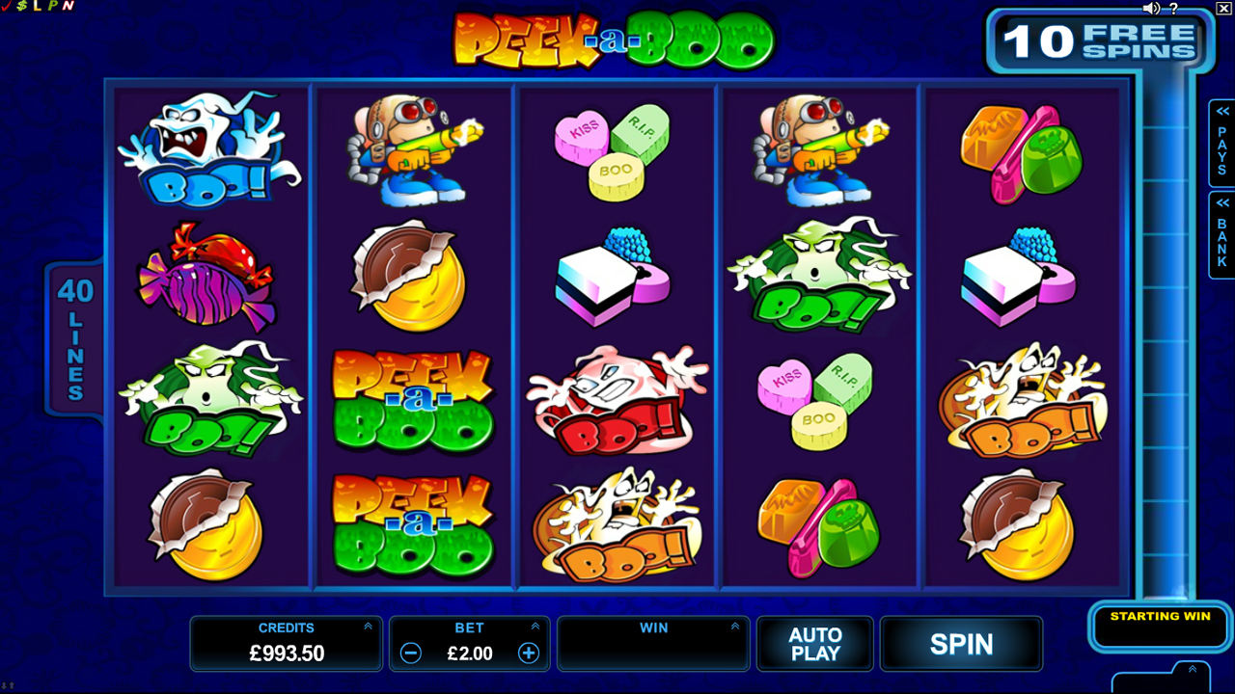

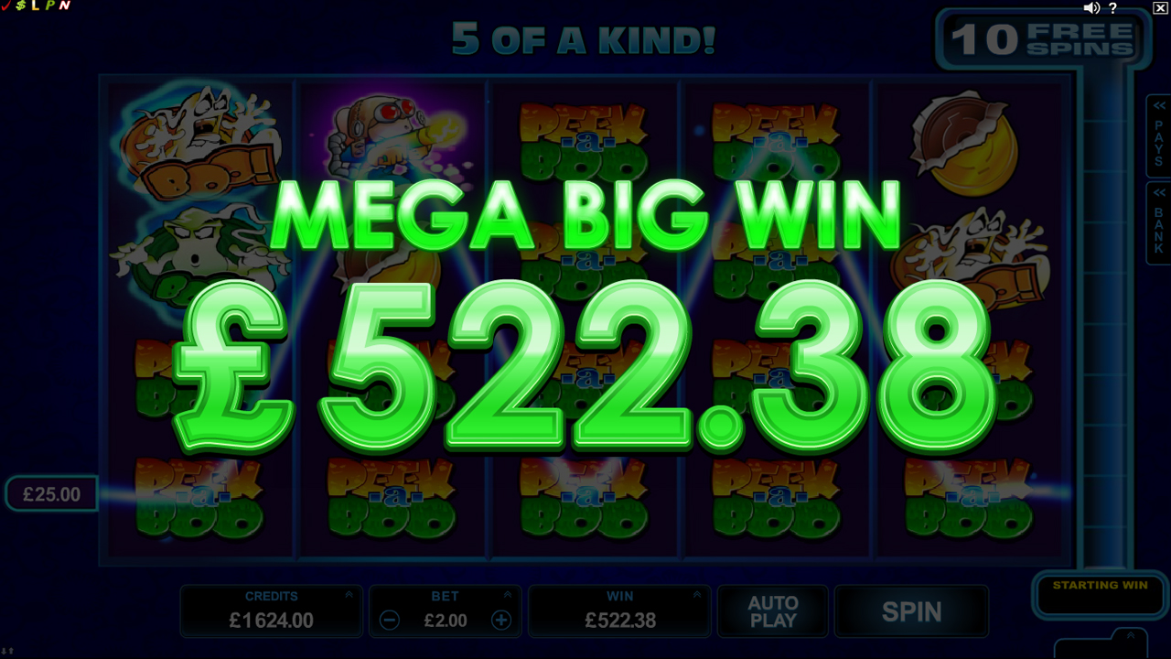

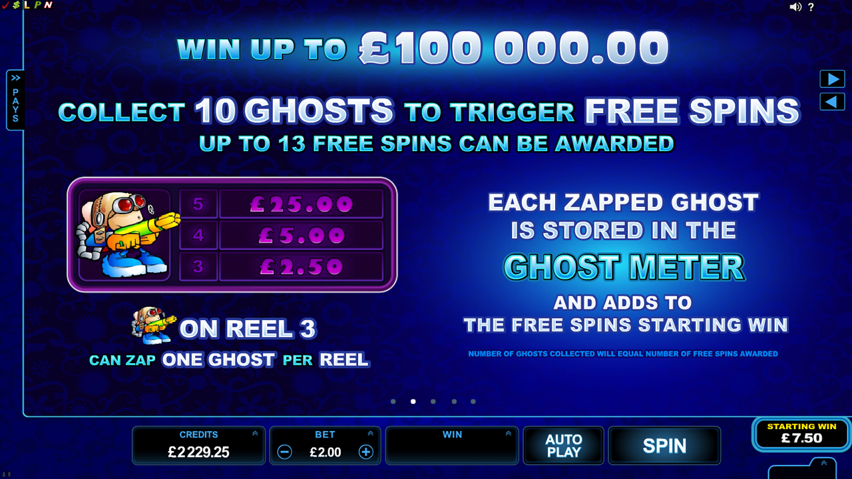

1. **Scary Friends**

crazy bunch of extra-terrestrial monsters in this latest release from Rabcat, Scary Friends. Get 3 or more scatter symbols in this 5 reel 25 payline game to activate the alarm and join the monsters celebrating their free spin party. Unlock the bonus feature with 3 or more bonus symbols and push the button the send these entertaining monsters into the air boosting your wins as they fly! For fun, entertainment and big wins Scary Friends should be your winner.

**Key Highlights:**

*Available on download, flash.*

*25 paylines*

*22 languages supported:*

***Full:****da, de, el, en, es, fi, fr, it, ja, ko, nl, no, pl, pt, pt-br, ru, sv, tr, zh, zh-tw*

